Contents

**part 1 – Building the HTML structure** 2

**part 2 – Adding CSS to the HTML** 4

**part 3 – Adding Semantics** 8

**part 4 – Adding Styles to the Aside, footer and container** 10

**part 5 – Using Templates** 14

**part 6 – Adding Styles to the Form** 18

**part 7 – Adding a Logo** 22

## part 1 – Building the HTML structure

(**download Day02-Starter-Code**)

|  |
| --- |
| **On Day02, you are given starter files consisting of an HTML document, a connected Style sheet and an image. These files will be added to and changed throughout this course.** |

1. Download the Day02-Starter-Code and unzip it, rename that folder to HTML. Do this in the parent folder of Day01. Once done, your parent folder should have two inner folders Day01 and HTML. Your HTML folder will contain all the starter code you need for today. Open that folder’s files in your editor.

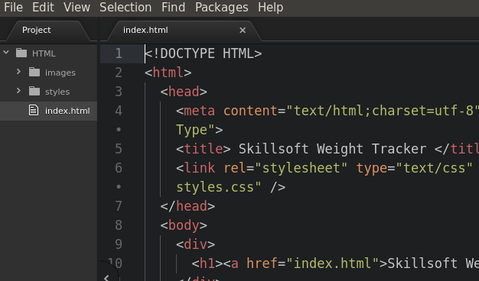

1. 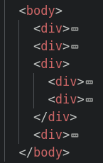There should be 4 major sectional areas, page-header(9), navigation(12), container(20) and footer(43):
2. Add id attributes to the major div tags so that we can target those HTML chunks in the CSS and later JavaScript.

|  |
| --- |
| <!DOCTYPE HTML>  <html>  <head>  <meta content="text/html;charset=utf-8" http-equiv="Content-Type">  <title> Skillsoft Weight Tracker </title>  <link rel="stylesheet" type="text/css" href="styles/styles.css" />  </head>  <body>  <div id="page-header">  <h1><a href="index.html">Skillsoft Weight Tracker</a></h1>  </div>  <div id="navigation">  <ul>  <li><a href="index.html">home</a></li>  <li><a href="enterweight.html">enter weight</a></li>  <li><a href="myweights.html">my weight</a></li>  <li><a href="teamweights.html">team weights</a></li>  </ul>  </div>  <div id="container">  <div>  <h2>How to Participate in the Program</h2>  <p>Lorem ipsum dolor sit amet, consectetur adipiscing elit, sed do eiusmod tempor incididunt ut labore et dolore magna aliqua.</p>  <p>Ut enim ad minim veniam, quis nostrud exercitation ullamco laboris nisi ut aliquip ex ea commodo consequat. Duis aute irure dolor in reprehenderit in voluptate velit esse cillum dolore eu fugiat nulla pariatur.</p>  <p>Ut enim ad minim veniam, quis nostrud exercitation ullamco laboris nisi ut aliquip ex ea commodo consequat. Duis aute irure dolor in reprehenderit in voluptate velit esse cillum dolore eu fugiat nulla pariatur.</p>  </div>  <div>  <div>  <h4>Health News</h4>  <p>  Lorem ipsum dolor sit amet, consectetur adipiscing elit, sed do eiusmod tempor incididunt ut labore et dolore magna aliqua.  </p>  </div>  <div>  <h4>Healthy Recipes</h4>  <a href="">grilled chicken</a>  <a href="">minced beef patties</a>  <a href="">potato pancakes</a>  <a href="">fish stew</a>  </div>  </div>  </div>  <div id="footer">  <hr />  Copyright &copy; 2019. All rights reserved  </div>  </body>  </html> |

1. The div with id of “container” will hold our **main content** area, but the right side is a separate area that shows news and recipes, this will be our **aside**. Lets name these two inner divs accordingly.  
   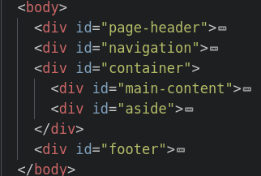
2. We can also id the two pairs of div tags within the aside area

|  |
| --- |
| </div>  <div id="aside">  <div id="section">  <h4>Health News</h4>  <p>  Lorem ipsum dolor sit amet, consectetur …  </p>  </div>  <div id="section">  <h4>Healthy Recipes</h4>  <a href="">grilled chicken</a>  <a href="">minced beef patties</a>  <a href="">potato pancakes</a>  <a href="">fish stew</a>  </div>  </div>  </div>  <div id="footer">  <hr /> |

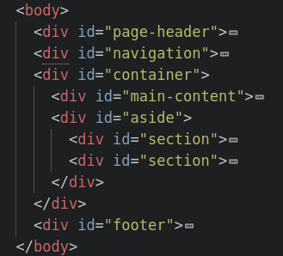

At this point you can open the index.html file in a browser and notice that it already has a few styles applied.

## part 2 – Adding CSS to the HTML

1. Open the styles.css file in your editor. We would need to give our **page-header** **div** a background color of black

|  |
| --- |
| **#page-header{**  **background-color:#000;**  **}** |

1. Lets style the **h1** tag inside of the **pageheader** **div** so that it has some space around it and it jams up against the top left corner. In this case **h1** is a decedent of the **pageheader** **div**.

|  |
| --- |
| **#page-header h1 {**  **padding: 5px 10px;**  **margin:0;**  **}** |

1. Turn the color of the **pageheader** text to red using the following style. Note we could not put the color into the style above because then the red text will have to compete with the black.

|  |
| --- |
| **#page-header h1 a {**  **color:red;**  **}** |

1. The rendered file at this point should look like the image below:  
     
   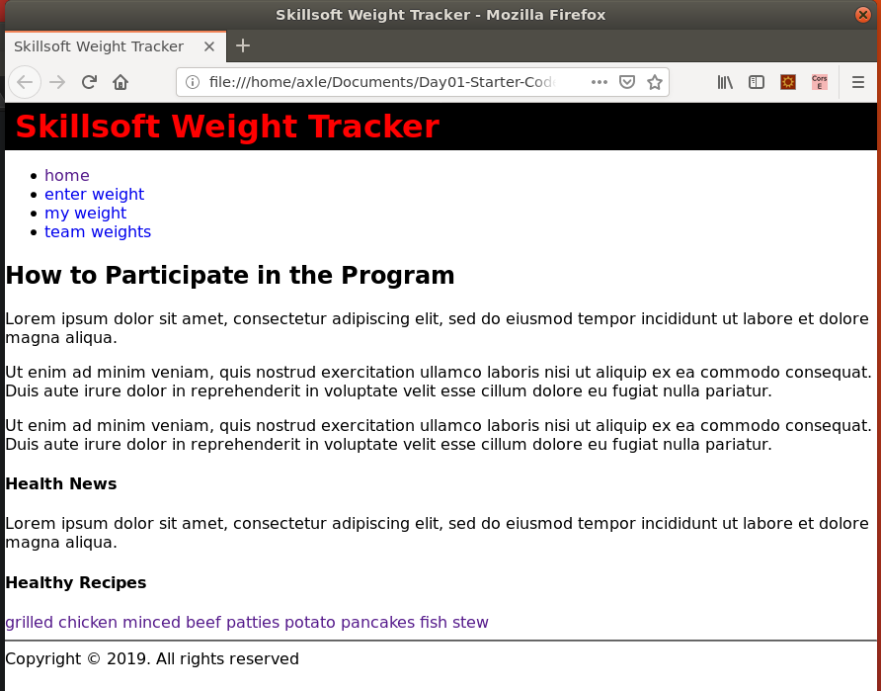
2. Let’s now work on the **navigation div**, add the following styles to the tag in a general way:

|  |
| --- |
| **#navigation{**  **text-align:left;**  **background-color:lightgray;**  **border-bottom:1px solid gray;**  **}** |

This would add a background color, align all text to the left and create a subtle line on the bottom of that structure.

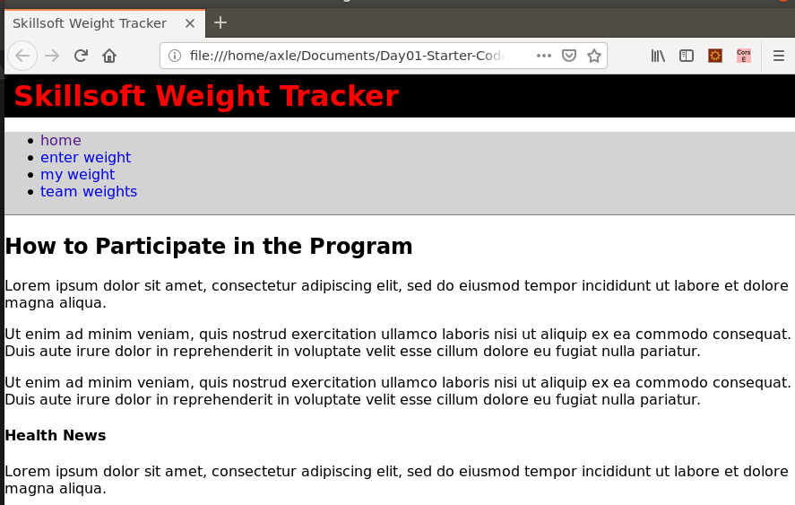

1. Display both the **list** **items** inside of navigation and the **anchor tags** inside of navigation as inline block items. Use of a comma here prevents us from writing two blocks of code.

|  |
| --- |
| **#navigation li, #navigation a {**  **display:inline-block;**  **}** |

The style would remove the bullets and cause the navigation links to show up horizontally. Whenever you see block, think of putting a square around the content that has the block style applied to it.

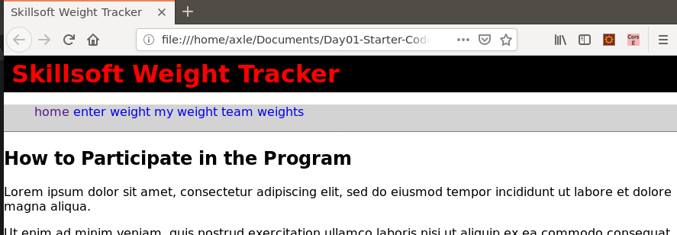

1. With the use of pseudo-classes we can change the state of an element, so let’s access the hover state of the **anchor tags** inside of the navigation area and change the background colour to light yellow when the mouse hovers over the links.

|  |
| --- |
| **#navigation a:hover{**  **background-color:lightyellow;**  **}** |

1. Let’s change the navigation links to black instead of the default blue color. Also add some space around each link (via the ‘a’ tag) so they don’t look crammed.

|  |
| --- |
| **#navigation a{**  **color:black;**  **padding: 10px 15px;**  **}** |

1. Remove any kind of spacing around the entire **ul** structure so that the navigation area is positioned directly next to the page header and no spaces are shown

|  |
| --- |
| **ul{**  **padding:0;**  **margin:0;**  **}** |

1. The rendered html file should now look like the one in the image below:

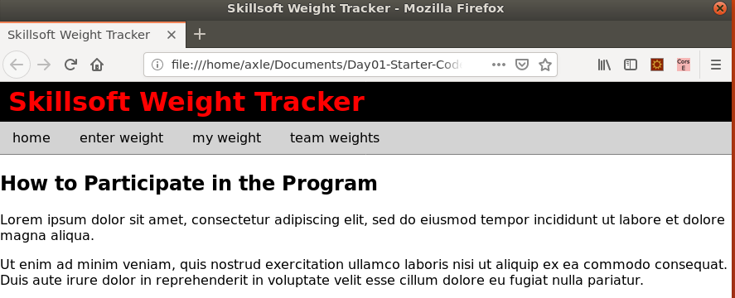

## part 3 – Adding Semantics

Semantic tags help other machines read and interpret HTML documents. There are several of them, but here are the main ones in a diagram:

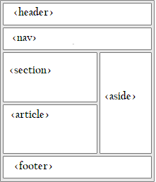

1. Visually inspect the HTML document in order to determine the various areas that apply to the semantic tags above:
2. Change the main tags to semantic ones, leaving only the container as a **div**

|  |
| --- |
| **<header>**  **<h1><a href="index.html">Skillsoft Weight Tracker</a></h1>**  **</header>**  **<nav>**  **<ul>**  **<li><a href="index.html">home</a></li>**  **<li><a href="enterweight.html">enter weight</a></li>**  **<li><a href="myweights.html">my weight</a></li>**  **<li><a href="teamweights.html">team weights</a></li>**  **</ul>**  **</nav>**  **<div id="container">**  **<main>**  **<h2>How to Participate in the Program</h2>**  **<p>Lorem ipsum dolor sit amet, consectetur adipiscing elit…</p>**  **<p>Ut enim ad minim veniam, quis nostrud exercitation….</p>**  **<p>Ut enim ad minim veniam, quis nostrud exercitation ullamco ….</p>**  **</main>**  **<aside>**  **<section>**  **<h4>Health News</h4>**  **<p>**  **Lorem ipsum dolor sit amet, consectetur adipiscing elit, sed do … </p>**  **</section>**  **<section>**  **<h4>Healthy Recipes</h4>**  **<a href="">grilled chicken</a>**  **<a href="">minced beef patties</a>**  **<a href="">potato pancakes</a>**  **<a href="">fish stew</a>**  **</section>**  **</aside>**  **</div>**  **<footer>**  **<hr />**  **Copyright &copy; 2019. All rights reserved**  **</footer>** |

1. Now change the tags in the css to match those on the html document

|  |
| --- |
| **header{**  **background-color:#000;**  **}**  **header h1 {**  **padding: 5px 10px;**  **margin:0;**  **}**  **header h1 a {**  **color:red;**  **}**  **nav{**  **text-align:left;**  **background-color:lightgray;**  **border-bottom:1px solid gray;**  **}**  **nav li, nav a {**  **display:inline-block;**  **}**  **nav a:hover{**  **background-color:lightyellow;**  **}**  **nav a{**  **color:black;**  **padding: 10px 15px;**  **}**  **ul{**  **padding:0;**  **margin:0;**  **}** |

## part 4 – Adding Styles to the Aside, footer and container

1. In order to have the **aside** and **sections** move to the right side of the page and leave the main content on the left we need to force sizes onto these big areas. Add the following style to the **main** tag in style.css:

|  |
| --- |
| **main{**  **float:left;**  **width:560px;**  **border-right: 1px solid #eeeeee;**  **}** |

1. At the same time add this style to the **div** with **id** of aside:

|  |
| --- |
| **aside{**  **float:left;**  **width:200px;**  **padding-bottom:10px;**  **padding-left: 4px;**  **}** |

So far …

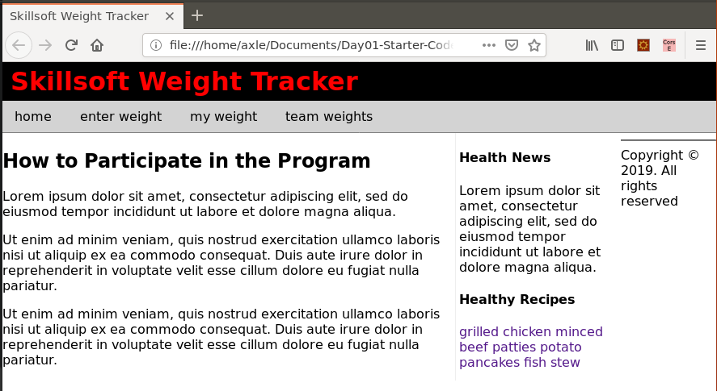

1. We need to add a style to force that **footer** to force it to stay at the bottom of the page:

|  |
| --- |
| **footer{**  **clear:both;**  **text-align:center;**  **font-size:.8em;**  **padding-top:50px;**  **}** |

1. Now the **maincontainer** and the **footer** divs need to have their **widths** contained a bit, so add this style in style.css to both tags:

|  |
| --- |
| **#container, footer{**  **width:90%;**  **margin: 0 auto;**  **margin-bottom: 60px;**  **}** |

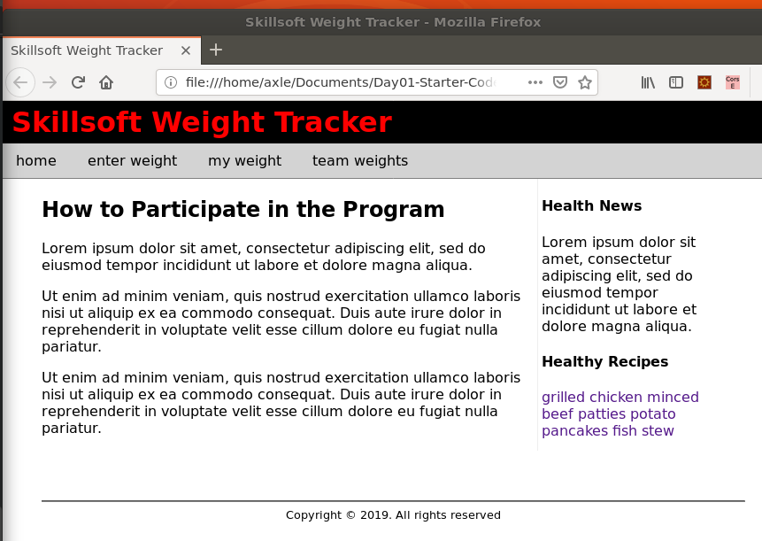

1. The links in the bottom section of the **aside** area should show up as individual links so add the following style. This will also add a subtle line between each link.

|  |
| --- |
| **aside section a{**  **display:block;**  **padding: 6px;**  **border-bottom: 1px solid lightgray;**  **color:black;**  **}** |

1. The CSS file should now look like this:

|  |
| --- |
| **html {**  **height: 100%;**  **}**  **body {**  **margin:0;**  **padding:0;**  **font-family: Verdana, Geneva, sans-serif;**  **}**  **a {**  **text-decoration:none;**  **}**  **header{**  **background-color:#000;**  **}**  **header h1 {**  **padding: 5px 10px;**  **margin:0;**  **}**  **header h1 a {**  **color:red;**  **}**  **nav{**  **text-align:left;**  **background-color:lightgray;**  **border-bottom:1px solid gray;**  **}**  **nav li, nav a {**  **display:inline-block;**  **}**  **nav a:hover{**  **background-color:lightyellow;**  **}**  **nav a{**  **color:black;**  **padding: 10px 15px;**  **}**  **ul{**  **padding:0;**  **margin:0;**  **}**  **main{**  **float:left;**  **width:560px;**  **border-right: 1px solid #eeeeee;**  **}**  **aside{**  **float:left;**  **width:200px;**  **padding-bottom:10px;**  **padding-left: 4px;**  **}**  **footer{**  **clear:both;**  **text-align:center;**  **font-size:.8em;**  **padding-top:50px;**  **}**  **#container, footer{**  **width:90%;**  **margin: 0 auto;**  **margin-bottom: 60px;**  **}**  **aside section a{**  **display:block;**  **padding: 6px;**  **border-bottom: 1px solid lightgray;**  **color:black;**  **}** |

The rendered HTML file should look like the image below:

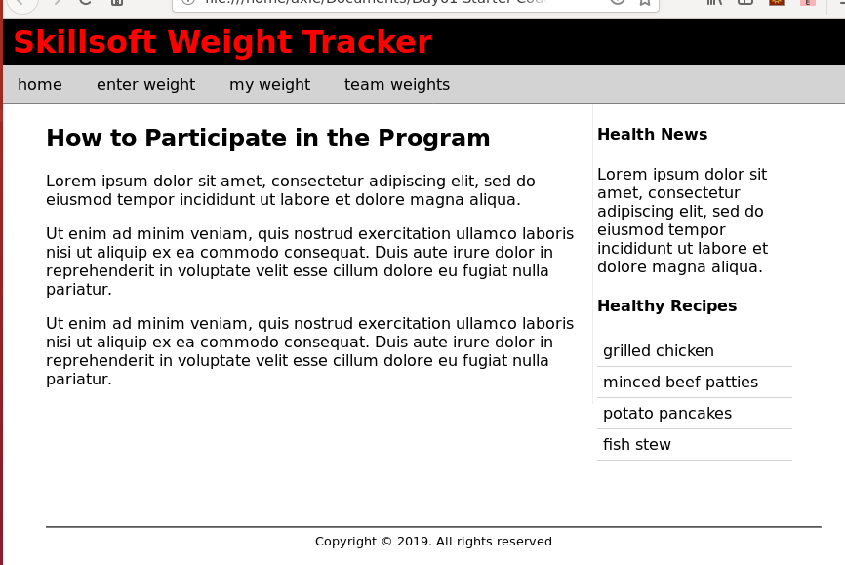

**NOTE: you may need to stretch the browser window to see this view otherwise the aside will drop to the bottom.**

## part 5 – Using Templates

**Note: the additional 3 html files will be provided to the participants.**

**Day02-Part5.zip on GitHub**

1. Now that we have index.html, we can use it as a template to construct the other 3 html files.
2. Copy index.html four more times and rename the files according to our navigation items, so enterweight.html, myweights.html, and teamweights.html.
3. Now we need to restructure the code and content in each file, starting with the myweights.html file, this should allow someone to enter her name then see a list of all the weights and dates she has entered over time. For now this file will be just a dummy file. Remove everything between the **main** tags except the **h2** tag which we rename to “My Records”. Also insert a pair of **form** tags.

|  |
| --- |
| **</nav>**  **<div id="container">**  **<main>**  **<h2>My Records</h2>**  **<form>**  **</form>**  **</main>**  **<aside>** |

1. Continue developing the **form** tags by inserting (a) a **label** and (b) an **input** box for the name to be found. Also (c) insert a **button** tag.

|  |
| --- |
| **<div id="container">**  **<main>**  **<h2>My Records</h2>**  **<form>**  **<label for="empName">Name</label>**  **<input id="empName" type="text" />**  **<button>Find my records</button>**  **</form>**  **</main>**  **<aside>** |

1. Just after the closing **form** tag, add a few **p** or **div** tags to display dummy data

|  |
| --- |
| **<main>**  **<h2>My Records</h2>**  **<form>**  **<label for="empName">Name</label>**  **<input id="empName" type="text" />**  **<button>Find my records</button>**  **</form>**  **<p>On [date] you weighed [empWeight] Kgs.</p>**  **<p>On [date] you weighed [empWeight] Kgs.</p>**  **<p>On [date] you weighed [empWeight] Kgs.</p>**  **<p>On [date] you weighed [empWeight] Kgs.</p>**  **<p>On [date] you weighed [empWeight] Kgs.</p>**  **</main>**  **<aside>** |

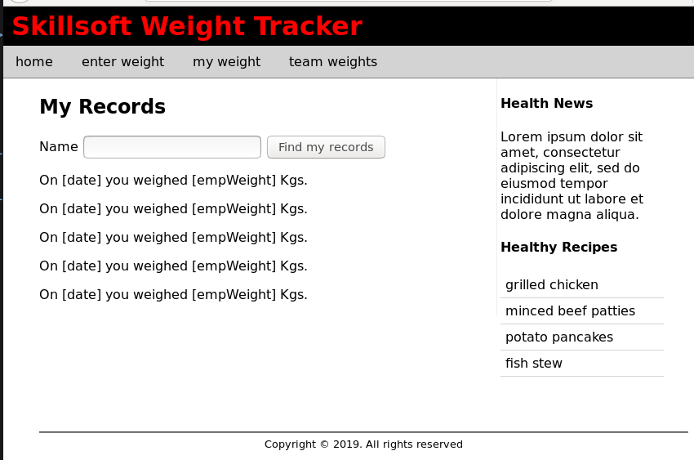

1. Do something similar for enterweight.html, except we would need both the *name* and *weight*, so 2 fields. Also change the text between the **h2** tags.

|  |
| --- |
| **<div id="container">**  **<main>**  **<h2>Enter your weight</h2>**  **<form>**  **<label for="empName">Your Name</label>**  **<input id="empName" type="text" />**  **<label for="empWeight">Your Weight Today</label>**  **<input id="empWeight" type="text" />**  **<button>Save Weight</button>**  **</form>**  **</main>**  **<aside>** |

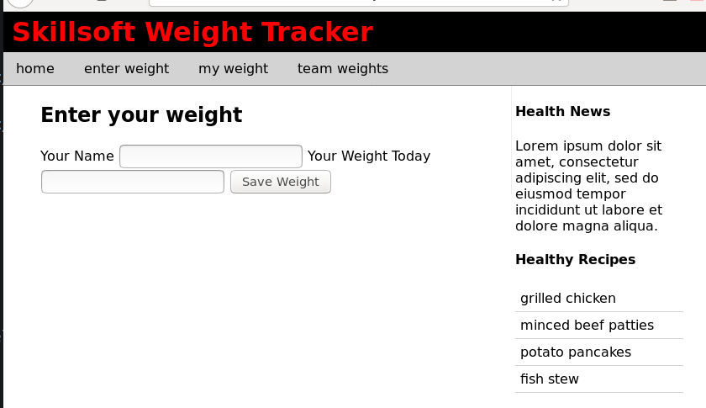

1. For teamweights.html simply replace the existing content we got from index.html with some dummy lines to represent records from our database

|  |
| --- |
| **</nav>**  **<div id="container">**  **<main>**  **<h2>Team Records</h2>**  **<p>On [date] [empName] weighed [empWeight] Kgs.</p>**  **<p>On [date] [empName] weighed [empWeight] Kgs.</p>**  **<p>On [date] [empName] weighed [empWeight] Kgs.</p>**  **<p>On [date] [empName] weighed [empWeight] Kgs.</p>**  **</main>**  **<aside>** |

Notice that we actually print the date, name and weight. Also change the section title to “Team Records”.

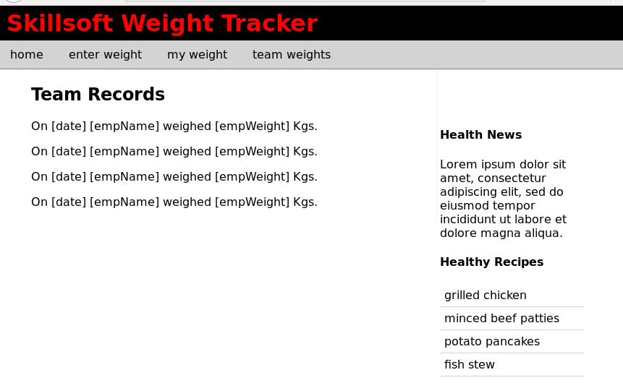

## part 6 – Adding Styles to the Form

1. So far, two html files will use forms, the myweights.html file and enterweight.html.
2. Before we style these forms, it would be better to wrap each label+input pair of tags into a container div, so do that in the html first. This gives us better control over the layout of these two items.
3. In myweights.html, add the container div to the label-input combination

|  |
| --- |
| **<h2>My Records</h2>**  **<form>**  **<div>**  **<label for="empName">Name</label>**  **<input id="empName" type="text" />**  **</div>**  **<button>Find my records</button>** |

1. We would need to do this for the button as well. This is because I wanted to keep all form elements left aligned in some way or at least look like they belong to one group.

|  |
| --- |
| **<form>**  **<div>**  **<label for="empName">Name</label>**  **<input id="empName" type="text" />**  **</div>**  **<div>**  **<button>Find my records</button>**  **</div>**  **</form>** |

1. The first style we apply is to have the label display as inline-block, give it an adequate width and align it’s text to the right so all labels will end close to where the input boxes begin. The style inline-block forces these objects to line up next to each other.

|  |
| --- |
| **label{**  **display:inline-block;**  **width:110px;**  **text-align:right;**  **}** |

1. That will put the label and input box next to each other but the button is still out of place, see image below.

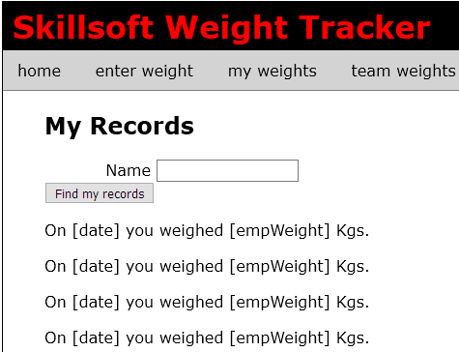

1. For the button, you may need to play with the numbers but I found that if we apply a margin-left value we may be able to place the button just underneath where the input box starts

|  |
| --- |
| **button{**  **margin-left:115px;**  **margin-top:10px;**  **}** |

1. We should apply the same technique to the form elements on the enterweight.html file, so wrap up the label-input combination inside of div tags as well as the button.

|  |
| --- |
| **<form>**  **<div>**  **<label for="empName">Your Name</label>**  **<input id="empName" type="text" />**  **</div>**  **<div>**  **<label for="empWeight">Your Weight Today</label>**  **<input id="empWeight" type="text" />**  **</div>**  **<div>**  **<button>Save Weight</button>**  **</div>**  **</form>** |

1. Look at the file in the browser and tweak the **width** property of the label tag in the style sheet so that the labels are all in one line. The following changes were made:

|  |
| --- |
| **label{**  **display:inline-block;**  **width:150px;**  **text-align:right;**  **}**  **button{**  **margin-left:155px;**  **margin-top:10px;**  **}** |

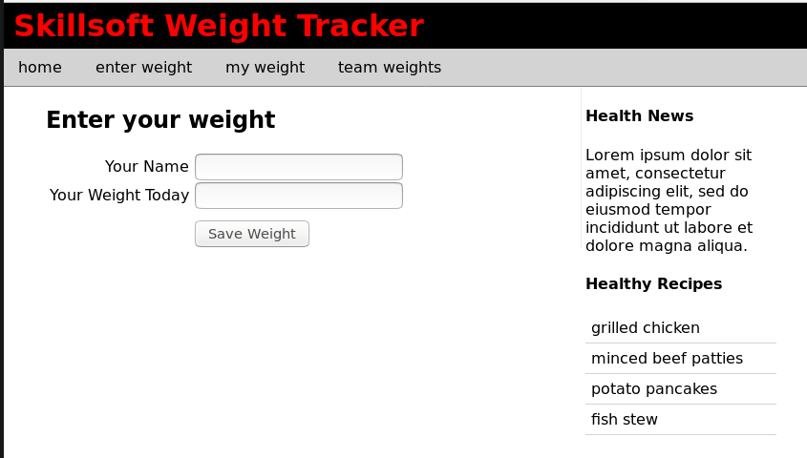

1. We should also separate the two sets of form elements with some space. It would be better to do this with a class as we don’t want to affect all divs. The following table box shows the class on the left and the html change to the enterweight.html on the right.

|  |  |
| --- | --- |
| **.formSeparator{**  **margin-top:10px;**  **}** | **<form>**  **<div>**  **<label for="empName">Your Name</label>**  **<input id="empName" type="text" />**  **</div>**  **<div class="formSeparator">**  **<label for="empWeight">Your Weight Today</label>**  **<input id="empWeight" type="text" />**  **</div>**  **<div>** |

1. The final look  
     
   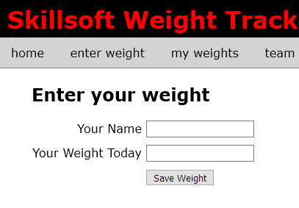
2. The myweights.html file should be ok as well.

## part 7 – Adding a Logo

1. Open index.html file and add a link to the logo image located in the images folder. Do this in the header tag
2. Give the image an id of “logo”.

|  |
| --- |
| **<body>**  **<header>**  **<img src="images/chart.gif" id="logo" />**  **<h1><a href="index.html">Skillsoft Weight Tracker</a></h1>**  **</header>**  **<nav>** |

Now apply the styles

|  |
| --- |
| **#logo{**  **float:right;**  **width:160px;**  **height:88px;**  **}** |

1. Finally add at least one meta-tag so that we don’t keep getting a browser error when we start using the developer tools

|  |
| --- |
| **<html>**  **<head>**  **<title> Skillsoft Weight Tracker </title>**  **<link rel="stylesheet" type="text/css" href="styles/styles.css" />**  **<meta content="text/html;charset=utf-8" http-equiv="Content-Type">**  **</head>**  **<body>** |

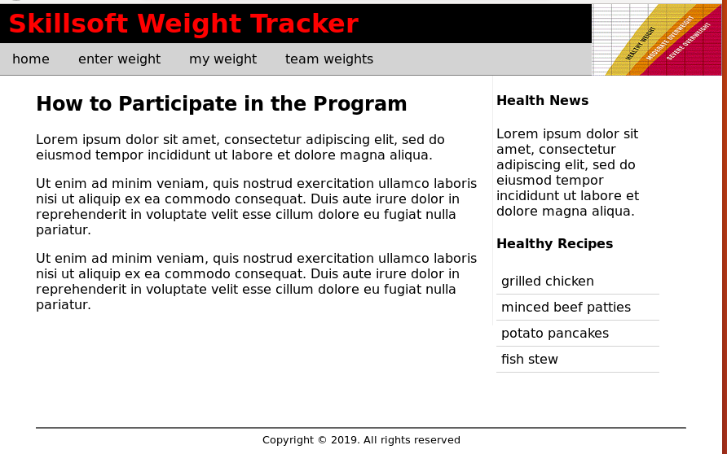  
4. Copy the img tag line to all other html files

**You may now download Day02-Part07-HTML.zip from GitHub for the complete set of HTML + CSS files**